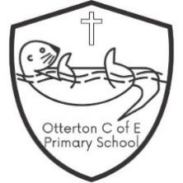
Otterton C of E Primary School
Headline Data 2022-2023

EYFS
Good level of development = 55%
Phonics Screening Year 1
Passed = 80%
Phonics Screening Year 2
Passed = 100%
Key Stage One
 | Reading | Writing | Maths | R, W, M
Pre- Key Stage  (Working below the level of the test) | 0% | 67% | 33% | 0%
Working Towards | 67% | 0% | 33% | 0%
Expected | 33% | 33% | 33% | 33%
Greater Depth | 0% | 0% | 0% | 0%

Key Stage Two
 | Reading | Writing | Maths | SPAG | R, W, M
Expected | 71% | 71% | 57% | 57% | 57%
Greater Depth | 43% | 0% | 14% | 0% | 0%
Average Scaled Score | 105.6 | - | 100.6 | 102.1

Progress from KS1 to KS2
Reading | 1.98
Writing | 0.99
Maths | -2.45

