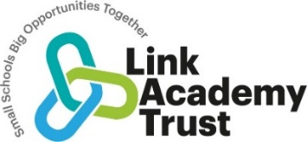

**Otterton C of E Academy Strategic Improvement Priorities**

**KEY IMPROVEMENT PRIORITIES for 2022-2023**