
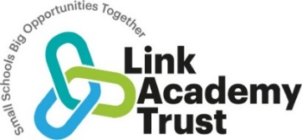
Otterton C of E Academy Strategic Improvement Priorities
Key Improvement Priorities for 2023-2024

Becoming SIAMs ready and gaining knowledge of the new framework.



Developing metacognition and self – regulated learning
.

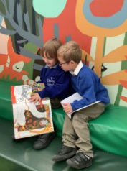

Developing a Relational Approach to Behaviour



Curriculum Development
.

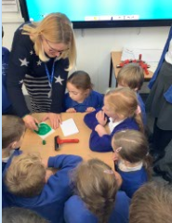

Developing children’s understanding of Life in Modern Britain



Key Priority 5
Key Priority 1
Key Priority 3
Key Priority 2
Key Priority 4

