
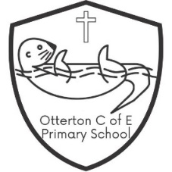
5 Star Pledge

At Otterton Primary School we offer children a wide range of exciting and ambitious learning opportunities, including:

- To learn, play and explore the ‘Great Outdoors’

- To take part in a ‘live’ performance in front of an audience

- To work closely and collaboratively with children from all age groups

- To take part in a sports tournament against pupils from outside of our schools

- To engage with and be active in the local community

